Non-uniform grid stencils

This document contains the derivation of the 1st and 2nd derivative of a function using function values at locations $x_{i}$, $α_{k}$ and $β_{j}$ with respective indexes. Below are diagrams of the possible stencils that may be made from the results of this document. The following analysis is valid for non-uniform grids.

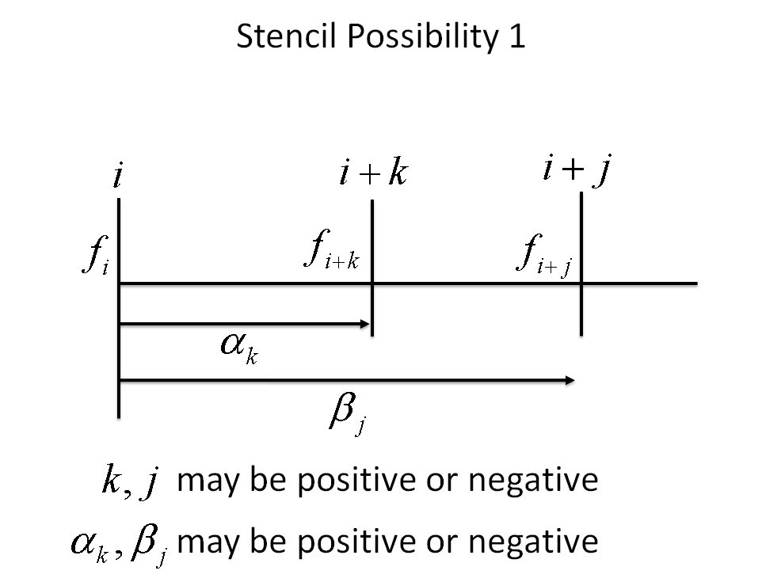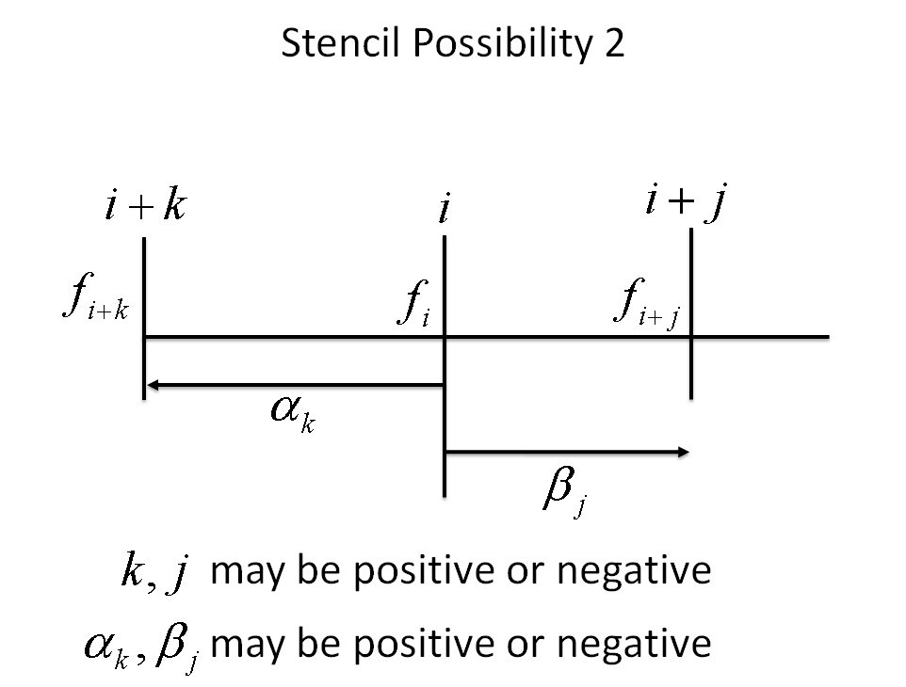

# Results

These results were obtained by solving the following system of equations

$$f_{i+k}=f_{i}+α_{k}f_{i}^{'}+\frac{1}{2}{α_{k}}^{2}f_{i}^{''}+O\left(α_{k}^{3}\right)$$

$$f_{i+j}=f_{i}+β_{j}f_{i}^{'}+\frac{1}{2}{β_{j}}^{2}f_{i}^{''}+O\left({β_{j}}^{3}\right)$$

$$f_{i+k}=f_{i}+α_{k}f_{i}^{'}+\frac{1}{2}{α_{k}}^{2}f_{i}^{''}+\frac{1}{3!}{α_{k}}^{3}f_{i}^{'''}+O\left(α_{k}^{4}\right)$$

$$f_{i+j}=f_{i}+β_{j}f_{i}^{'}+\frac{1}{2}{β_{j}}^{2}f_{i}^{''}+\frac{1}{3!}{β_{j}}^{3}f_{i}^{'''}+O\left({β_{j}}^{4}\right)$$

## 1st derivative

$$\boxed{f_{i}^{'}=\frac{1}{\left(β_{j}-α_{k}\right)}\left\{f_{i}\left(\frac{α_{k}}{β_{j}}-\frac{β_{j}}{α_{k}}\right)+\frac{β_{j}}{α_{k}}f_{i+k}-\frac{α_{k}}{β_{j}}f_{i+j}\right\}+O\left(α_{k}β_{j}\right)} α_{k}≠β_{j}$$

## 2nd derivative

$$\boxed{f_{i}^{''}=\frac{2f_{i}}{α_{k}β_{j}}+\frac{2f_{i+k}}{{α_{k}}^{2}-α_{k}β_{j}}+\frac{2f_{i+j}}{{β_{j}}^{2}-β_{j}α_{k}}+O\left(-β_{j}α_{k}-\left(β_{j}+α_{k}\right)\right)}$$

# Derivation

A function may be approximated at location $α_{k}$ from location $x_{i}$ as

$$f_{i+k}=f_{i}+α_{k}f_{i}^{'}+\frac{1}{2}{α_{k}}^{2}f_{i}^{''}+\frac{1}{3!}{α_{k}}^{3}f_{i}^{'''}+O\left(α_{k}^{4}\right)$$

In addition, the function may be approximated at location $β_{j}$ from location $x_{i}$ as

$$f_{i+j}=f_{i}+β_{j}f_{i}^{'}+\frac{1}{2}{β_{j}}^{2}f_{i}^{''}+\frac{1}{3!}{β_{j}}^{3}f_{i}^{'''}+O\left({β_{j}}^{4}\right)$$

Multiplying the first equation by the appropriate coefficient:

$$-{\left(\frac{β_{j}}{α_{k}}\right)}^{γ}\left\{f_{i+k}=f_{i}+α_{k}f_{i}^{'}+\frac{1}{2}{α_{k}}^{2}f_{i}^{''}+\frac{1}{3!}{α_{k}}^{3}f_{i}^{'''}+O\left(α_{k}^{4}\right)\right\}$$

$$f_{i+j}=f_{i}+β_{j}f_{i}^{'}+\frac{1}{2}{β_{j}}^{2}f_{i}^{''}+\frac{1}{3!}{β_{j}}^{3}f_{i}^{'''}+O\left(β_{j}^{4}\right)$$

Where $γ$ is some integer, and combining yields

$$f_{i+j}-{\left(\frac{β_{j}}{α_{k}}\right)}^{γ}f_{i+k}=f_{i}\left\{1-{\left(\frac{β_{j}}{α_{k}}\right)}^{γ}\right\}+f_{i}^{'}\left\{β_{j}-α_{k}{\left(\frac{β_{j}}{α_{k}}\right)}^{γ}\right\}+\frac{1}{2}f_{i}^{''}\left\{β_{j}^{2}-α_{k}^{2}{\left(\frac{β_{j}}{α_{k}}\right)}^{γ}\right\}+…$$

$$\frac{1}{3!}f_{i}^{'''}\left\{β_{j}^{3}-α_{k}^{3}{\left(\frac{β_{j}}{α_{k}}\right)}^{γ}\right\}+O\left(β_{j}^{4}-{\left(\frac{β_{j}}{α_{k}}\right)}^{γ}α_{k}^{4}\right)$$

Where $γ$ is the order, or term, you wish to cancel. Now, to make this analysis more specific, we will aim to focus on 2nd order accurate equations. Therefore, for 1st and 2nd derivatives, $γ$ will be 2 and 3 respectively. Let's look at these cases separately.

# 1st derivative

For the 1st derivative, we would like to cancel the 2nd order term. i.e. $γ=2$

$$f_{i+j}-{\left(\frac{β_{j}}{α_{k}}\right)}^{2}f_{i+k}=f_{i}\left\{1-{\left(\frac{β_{j}}{α_{k}}\right)}^{2}\right\}+f_{i}^{'}\left\{β_{j}-α_{k}{\left(\frac{β_{j}}{α_{k}}\right)}^{2}\right\}+\frac{1}{2}f_{i}^{''}\left\{β_{j}^{2}-α_{k}^{2}{\left(\frac{β_{j}}{α_{k}}\right)}^{2}\right\}+O\left(β_{j}^{3}-{\left(\frac{β_{j}}{α_{k}}\right)}^{2}α_{k}^{3}\right)$$

Which simplifies to

$$f_{i+j}-{\left(\frac{β_{j}}{α_{k}}\right)}^{2}f_{i+k}=f_{i}\left\{1-{\left(\frac{β_{j}}{α_{k}}\right)}^{2}\right\}+f_{i}^{'}\left\{β_{j}-α_{k}{\left(\frac{β_{j}}{α_{k}}\right)}^{2}\right\}+O\left(β_{j}^{3}-β_{j}^{2}α_{k}\right)$$

Or

$$f_{i+j}-{\left(\frac{β_{j}}{α_{k}}\right)}^{2}f_{i+k}=f_{i}\left\{1-{\left(\frac{β_{j}}{α_{k}}\right)}^{2}\right\}+f_{i}^{'}\left\{β_{j}-α_{k}{\left(\frac{β_{j}}{α_{k}}\right)}^{2}\right\}+O\left(β_{j}^{2}α_{k}\left(\frac{β_{j}}{α_{k}}-1\right) \right)$$

Solving for the derivative at location $i$ yields

$$f_{i}^{'}=\frac{f_{i+j}-{\left(\frac{β_{j}}{α_{k}}\right)}^{2}f_{i+k}-f_{i}\left(1-{\left(\frac{β_{j}}{α_{k}}\right)}^{2}\right)}{\left\{β_{j}-α_{k}{\left(\frac{β_{j}}{α_{k}}\right)}^{2}\right\}}+O\left(\frac{β_{j}^{2}α_{k}\left(\frac{β_{j}}{α_{k}}-1\right) }{\left\{β_{j}-α_{k}{\left(\frac{β_{j}}{α_{k}}\right)}^{2}\right\}}\right)$$

The order term may also be written as

$$\frac{β_{j}^{2}α_{k}\left(\frac{β_{j}}{α_{k}}-1\right) }{\left\{β_{j}-α_{k}{\left(\frac{β_{j}}{α_{k}}\right)}^{2}\right\}}=\frac{β_{j}^{2}α_{k}\left(\frac{β_{j}}{α_{k}}-1\right) }{-\left\{α_{k}{\left(\frac{β_{j}}{α_{k}}\right)}^{2}-β_{j}\right\}}=\frac{β_{j}^{2}α_{k}\left(\frac{β_{j}}{α_{k}}-1\right) }{-α_{k}\left\{{\left(\frac{β_{j}}{α_{k}}\right)}^{2}-\frac{β_{j}}{α_{k}}\right\}}=\frac{β_{j}^{2}α_{k}\left(\frac{β_{j}}{α_{k}}-1\right) }{-α_{k}\frac{β_{j}}{α_{k}}\left\{\frac{β_{j}}{α_{k}}-1\right\}}=$$

Doing some algebra this may be written as

$$\boxed{f_{i}^{'}=\frac{1}{\left(β_{j}-α_{k}\right)}\left\{f_{i}\left(\frac{α_{k}}{β_{j}}-\frac{β_{j}}{α_{k}}\right)+\frac{β_{j}}{α_{k}}f_{i+k}-\frac{α_{k}}{β_{j}}f_{i+j}\right\}+O\left(α_{k}β_{j}\right)} α_{k}≠β_{j}$$

This is the 1st derivative of $f$ at location $i$ using locations $α_{k}$ and $β_{j}$, with $O\left(α_{k}β_{j}\right)$ order accuracy. $f_{k}$ is located at $x_{i}+α_{k}$ and $f_{j}$ is located at $x_{i}+β_{j}$. There is no sign restriction on $α_{k}$ or $β_{j}$. This equation is valid for non-uniform grids.

# 2nd derivative

For the 2nd derivative, we would like to cancel the 3rd order term. i.e. $γ=3$

$$f_{i+j}-{\left(\frac{β_{j}}{α_{k}}\right)}^{3}f_{i+k}=f_{i}\left\{1-{\left(\frac{β_{j}}{α_{k}}\right)}^{3}\right\}+f_{i}^{'}\left\{β_{j}-α_{k}{\left(\frac{β_{j}}{α_{k}}\right)}^{3}\right\}+\frac{1}{2}f_{i}^{''}\left\{β_{j}^{2}-α_{k}^{2}{\left(\frac{β_{j}}{α_{k}}\right)}^{3}\right\}+O\left(β_{j}^{4}-{\left(\frac{β_{j}}{α_{k}}\right)}^{3}α_{k}^{4}\right)$$

The problem here is that the 1st derivative still exists, so we must add the equation for the 1st derivative and weight it:

$$-\frac{\left\{β_{j}-α_{k}{\left(\frac{β_{j}}{α_{k}}\right)}^{3}\right\}}{\left\{β_{j}-α_{k}{\left(\frac{β_{j}}{α_{k}}\right)}^{2}\right\}}\left\{f_{i+j}-{\left(\frac{β_{j}}{α_{k}}\right)}^{2}f_{i+k}=f_{i}\left\{1-{\left(\frac{β_{j}}{α_{k}}\right)}^{2}\right\}+f_{i}^{'}\left\{β_{j}-α_{k}{\left(\frac{β_{j}}{α_{k}}\right)}^{2}\right\}+O\left(β_{j}^{3}-β_{j}^{2}α_{k}\right)\right\}$$

The weight may also be written as

$$-\frac{\left\{β_{j}-α_{k}{\left(\frac{β_{j}}{α_{k}}\right)}^{3}\right\}}{\left\{β_{j}-α_{k}{\left(\frac{β_{j}}{α_{k}}\right)}^{2}\right\}}=-\frac{\left\{1-{\left(\frac{β_{j}}{α_{k}}\right)}^{2}\right\}}{\left\{1-\frac{β_{j}}{α_{k}}\right\}}=-\frac{\left(\frac{β_{j}}{α_{k}}+1\right)\left(\frac{β_{j}}{α_{k}}-1\right)}{\left(\frac{β_{j}}{α_{k}}-1\right)}=-\left(\frac{β_{j}}{α_{k}}+1\right)$$

Adding these equations:

$$f_{i+j}-{\left(\frac{β_{j}}{α_{k}}\right)}^{3}f_{i+k}=f_{i}\left\{1-{\left(\frac{β_{j}}{α_{k}}\right)}^{3}\right\}+f_{i}^{'}\left\{β_{j}-α_{k}{\left(\frac{β_{j}}{α_{k}}\right)}^{3}\right\}+\frac{1}{2}f_{i}^{''}\left\{β_{j}^{2}-α_{k}^{2}{\left(\frac{β_{j}}{α_{k}}\right)}^{3}\right\}+O\left(β_{j}^{4}-{\left(\frac{β_{j}}{α_{k}}\right)}^{3}α_{k}^{4}\right)$$

$$-\left(\frac{β_{j}}{α_{k}}+1\right)\left\{f_{i+j}-{\left(\frac{β_{j}}{α_{k}}\right)}^{2}f_{i+k}=f_{i}\left\{1-{\left(\frac{β_{j}}{α_{k}}\right)}^{2}\right\}+f_{i}^{'}\left\{β_{j}-α_{k}{\left(\frac{β_{j}}{α_{k}}\right)}^{2}\right\}+O\left(β_{j}^{3}-β_{j}^{2}α_{k}\right)\right\}$$

Yields

$$f_{i+j}-{\left(\frac{β_{j}}{α_{k}}\right)}^{3}f_{i+k}-\left(\frac{β_{j}}{α_{k}}+1\right)\left(f_{i+j}-{\left(\frac{β_{j}}{α_{k}}\right)}^{2}f_{i+k}\right)=f_{i}\left\{1-{\left(\frac{β_{j}}{α_{k}}\right)}^{3}\right\}-f_{i}\left(\frac{β_{j}}{α_{k}}+1\right)\left\{1-{\left(\frac{β_{j}}{α_{k}}\right)}^{2}\right\}+…$$

$$0+\frac{1}{2}f_{i}^{''}\left\{β_{j}^{2}-α_{k}^{2}{\left(\frac{β_{j}}{α_{k}}\right)}^{3}\right\}+O\left(β_{j}^{4}-{\left(\frac{β_{j}}{α_{k}}\right)}^{3}α_{k}^{4}\right)-\left(\frac{β_{j}}{α_{k}}+1\right)O\left(β_{j}^{3}-β_{j}^{2}α_{k}\right)$$

Simplifying the coefficient of the 2nd derivative term

$$\left\{β_{j}^{2}-α_{k}^{2}{\left(\frac{β_{j}}{α_{k}}\right)}^{3}\right\}=-{β_{j}}^{2}\left\{\frac{β_{j}}{α_{k}}-1\right\}$$

Yields

$$f_{i+j}-{\left(\frac{β_{j}}{α_{k}}\right)}^{3}f_{i+k}-\left(\frac{β_{j}}{α_{k}}+1\right)\left(f_{i+j}-{\left(\frac{β_{j}}{α_{k}}\right)}^{2}f_{i+k}\right)=f_{i}\left\{1-{\left(\frac{β_{j}}{α_{k}}\right)}^{3}\right\}-f_{i}\left(\frac{β_{j}}{α_{k}}+1\right)\left\{1-{\left(\frac{β_{j}}{α_{k}}\right)}^{2}\right\}+…$$

$$0-\frac{1}{2}f_{i}^{''}{β_{j}}^{2}\left\{\frac{β_{j}}{α_{k}}-1\right\}+O\left(β_{j}^{4}-{\left(\frac{β_{j}}{α_{k}}\right)}^{3}α_{k}^{4}\right)-\left(\frac{β_{j}}{α_{k}}+1\right)O\left(β_{j}^{3}-β_{j}^{2}α_{k}\right)$$

Solving for the second derivative term, and substituting the previously calculated order of accuracy yields

$$f_{i}^{''}=\frac{2}{{β_{j}}^{2}\left\{\frac{β_{j}}{α_{k}}-1\right\}}\left\{f_{i}\left\{1-{\left(\frac{β_{j}}{α_{k}}\right)}^{3}\right\}-f_{i}\left(\frac{β_{j}}{α_{k}}+1\right)\left\{1-{\left(\frac{β_{j}}{α_{k}}\right)}^{2}\right\}+\left(\frac{β_{j}}{α_{k}}+1\right)\left(f_{i+j}-{\left(\frac{β_{j}}{α_{k}}\right)}^{2}f_{i+k}\right)+{\left(\frac{β_{j}}{α_{k}}\right)}^{3}f_{i+k}-f_{i+j}\right\}+O\left(-β_{j}α_{k}-\left(β_{j}+α_{k}\right)\right)$$

Collecting terms yields

$$f_{i}^{''}=\frac{2}{{β_{j}}^{2}\left\{\frac{β_{j}}{α_{k}}-1\right\}}\left\{f_{i}\left(1-{\left(\frac{β_{j}}{α_{k}}\right)}^{3}-\left(\frac{β_{j}}{α_{k}}+1\right)\left\{1-{\left(\frac{β_{j}}{α_{k}}\right)}^{2}\right\}\right)+f_{i+k}\left({\left(\frac{β_{j}}{α_{k}}\right)}^{3}-\left(\frac{β_{j}}{α_{k}}+1\right){\left(\frac{β_{j}}{α_{k}}\right)}^{2}\right)+f_{i+j}\left(\left(\frac{β_{j}}{α_{k}}+1\right)-1\right)\right\}+O\left(-β_{j}α_{k}-\left(β_{j}+α_{k}\right)\right)$$

Let's simplify these terms separately

### First term

$$f_{i}\frac{2}{{β_{j}}^{2}\left\{\frac{β_{j}}{α_{k}}-1\right\}}\left(1-{\left(\frac{β_{j}}{α_{k}}\right)}^{3}-\left(\frac{β_{j}}{α_{k}}+1\right)\left\{1-{\left(\frac{β_{j}}{α_{k}}\right)}^{2}\right\}\right)$$

Factoring out the alpha yields

$$f_{i}\frac{2}{{β_{j}}^{2}\left\{\frac{β_{j}}{α_{k}}-1\right\}}\left(1-{\left(\frac{β_{j}}{α_{k}}\right)}^{3}-\left(\frac{β_{j}}{α_{k}}-{\left(\frac{β_{j}}{α_{k}}\right)}^{3}+1-{\left(\frac{β_{j}}{α_{k}}\right)}^{2}\right)\right)$$

$$=f_{i}\frac{2}{{β_{j}}^{2}\left\{\frac{β_{j}}{α_{k}}-1\right\}}\left(-\frac{β_{j}}{α_{k}}+{\left(\frac{β_{j}}{α_{k}}\right)}^{2}\right)$$

$$=f_{i}\frac{2}{{β_{j}}^{2}\left\{\frac{β_{j}}{α_{k}}-1\right\}}\frac{β_{j}}{α_{k}}\left(\frac{β_{j}}{α_{k}}-1\right)$$

$$={2f}_{i}\frac{1}{α_{k}β_{j}}$$

### Second term

$$f_{i+k}\frac{2}{{β_{j}}^{2}\left\{\frac{β_{j}}{α_{k}}-1\right\}}\left({\left(\frac{β_{j}}{α_{k}}\right)}^{3}-\left(\frac{β_{j}}{α_{k}}+1\right){\left(\frac{β_{j}}{α_{k}}\right)}^{2}\right)$$

$$f_{i+k}\frac{2}{{β_{j}}^{2}\left\{\frac{β_{j}}{α_{k}}-1\right\}}\left({\left(\frac{β_{j}}{α_{k}}\right)}^{3}-\left({\left(\frac{β_{j}}{α_{k}}\right)}^{3}+{\left(\frac{β_{j}}{α_{k}}\right)}^{2}\right)\right)$$

$$f_{i+k}\frac{-2}{{β_{j}}^{2}\left\{\frac{β_{j}}{α_{k}}-1\right\}}{\left(\frac{β_{j}}{α_{k}}\right)}^{2}$$

$$=-2f_{i+k}\frac{1}{{α_{k}}^{2}\left\{\frac{β_{j}}{α_{k}}-1\right\}}$$

### Third term

$$f_{i+j}\frac{2}{{β_{j}}^{2}\left\{\frac{β_{j}}{α_{k}}-1\right\}}\left(\left(\frac{β_{j}}{α_{k}}+1\right)-1\right)$$

$$f_{i+j}\frac{2}{{β_{j}}^{2}\left\{\frac{β_{j}}{α_{k}}-1\right\}}\frac{β_{j}}{α_{k}}$$

$$f_{i+j}\frac{2}{β_{j}α_{k}\left\{\frac{β_{j}}{α_{k}}-1\right\}}$$

$$=2f_{i+j}\frac{1}{β_{j}α_{k}\left\{\frac{β_{j}}{α_{k}}-1\right\}}$$

Therefore, our final expression is

$$f_{i}^{''}=2f_{i}\frac{1}{α_{k}β_{j}}-2f_{i+k}\frac{1}{{α_{k}}^{2}\left\{\frac{β_{j}}{α_{k}}-1\right\}}+2f_{i+j}\frac{1}{β_{j}α_{k}\left\{\frac{β_{j}}{α_{k}}-1\right\}}+O\left(-β_{j}α_{k}-\left(β_{j}+α_{k}\right)\right)$$

Cleaning up we have

$$\boxed{f_{i}^{''}=\frac{2f_{i}}{α_{k}β_{j}}+\frac{2f_{i+k}}{\left\{{α_{k}}^{2}-α_{k}β_{j}\right\}}+\frac{2f_{i+j}}{\left\{{β_{j}}^{2}-β_{j}α_{k}\right\}}+O\left(-β_{j}α_{k}-\left(β_{j}+α_{k}\right)\right)}$$

# Derivation of order of accuracy for 2nd derivative

This weight of the first equation simplifies to

$$-\frac{\left\{β_{j}-α_{k}{\left(\frac{β_{j}}{α_{k}}\right)}^{3}\right\}}{\left\{β_{j}-α_{k}{\left(\frac{β_{j}}{α_{k}}\right)}^{2}\right\}}=-α_{k}\frac{\left\{1-{\left(\frac{β_{j}}{α_{k}}\right)}^{2}\right\}}{\left\{α_{k}-β_{j}\right\}}=α_{k}\frac{\left\{1-{\left(\frac{β_{j}}{α_{k}}\right)}^{2}\right\}}{(β_{j}-α_{k})}=\frac{\left\{1-{\left(\frac{β_{j}}{α_{k}}\right)}^{2}\right\}}{\left(\frac{β_{j}}{α_{k}}-1\right)}=-\frac{\left\{{\left(\frac{β_{j}}{α_{k}}\right)}^{2}-1\right\}}{\left(\frac{β_{j}}{α_{k}}-1\right)}=-\frac{\left(\frac{β_{j}}{α_{k}}+1\right)\left(\frac{β_{j}}{α_{k}}-1\right)}{\left(\frac{β_{j}}{α_{k}}-1\right)}$$

$$=-\left(\frac{β_{j}}{α_{k}}+1\right)$$

After dividing by the $f_{i}''$ coefficient, the order of accuracy will drop by a factor of

$$\left\{β_{j}^{2}-α_{k}^{2}{\left(\frac{β_{j}}{α_{k}}\right)}^{3}\right\}=β_{j}^{2}\left\{1-\frac{β_{j}}{α_{k}}\right\}=-{β_{j}}^{2}\left\{\frac{β_{j}}{α_{k}}-1\right\}$$

Therefore, the final order of accuracy will be the sum of the truncation from our 1st and 2nd derivative estimation terms

$$O=\underset{truncation from f^{''}equation}{\underbrace{\frac{O\left(β_{j}^{4}-{\left(\frac{β_{j}}{α_{k}}\right)}^{3}α_{k}^{4}\right)}{-{β_{j}}^{2}\left\{\frac{β_{j}}{α_{k}}-1\right\}}}}+\underset{truncation from f^{'}equation}{\underbrace{\frac{-\left(\frac{β_{j}}{α_{k}}+1\right)O\left(β_{j}^{3}-β_{j}^{2}α_{k}\right)}{-{β_{j}}^{2}\left\{\frac{β_{j}}{α_{k}}-1\right\}}}}$$

Simplifying these yields

$$O=\frac{β_{j}^{3}\left(β_{j}-α_{k}\right)}{-{β_{j}}^{2}\left\{\frac{β_{j}}{α_{k}}-1\right\}}+\frac{-\left(\frac{β_{j}}{α_{k}}+1\right)β_{j}^{2}\left(β_{j}-α_{k}\right)}{-{β_{j}}^{2}\left\{\frac{β_{j}}{α_{k}}-1\right\}}=-β_{j}α_{k}+\frac{\left(\frac{β_{j}}{α_{k}}+1\right)β_{j}^{2}α_{k} }{{β_{j}}^{2}}=$$

$$=-β_{j}α_{k}+α_{k}\left(\frac{β_{j}}{α_{k}}+1\right)=-β_{j}α_{k}+α_{k}\left(\frac{β_{j}}{α_{k}}+1\right)=-β_{j}α_{k}+\left(β_{j}+α_{k}\right)$$

For $α_{k}=Δx$ and $β_{j}=2Δx$ we have

$$O=(Δx^{2})$$

This confirms the simplifying case.